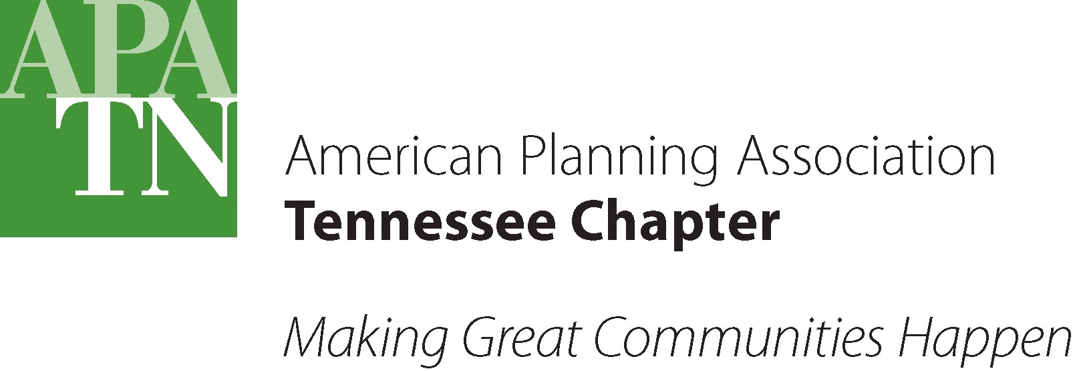

LOCAL PLANNING ASSISTANCE OFFICE: PUBLIC PLANNING SCHOLARSHIP

The Tennessee Chapter of the American Planning Association (TAPA) has established a $1,000 per year scholarship to be awarded on an annual basis to a current graduate student in an accredited Graduate program in Urban and Regional Planning, Urban Studies, or similar program as determined by the TAPA Executive Board. The TAPA “Local Planning Assistance Office Public Planning Scholarship” is designed to promote and educate students in the art and science of public planning, using the legacy of the Tennessee Local Planning Assistance Office to motivate graduate students to study and apply their insight to the unique challenges facing public sector planners.

The Tennessee Local Planning Assistance Office, originally the Tennessee State Planning Office, was from the mid-1930’s to 2011 a unique and widely-respected organization of State government that provided professional planning advice to any Tennessee city, town, or county that requested and contracted for service. Local Planning trained many young and not-so-young planners over the years, and supplied governments and private firms all over the United States with trained, experienced planners. Local Planning’s legacy of objective, professional planning advice, and devotion to public service served as an inspiration to those who worked with and worked within the Agency.

Recipients of the “Local Planning Assistance Office Public Planning Scholarship” must be holders of a 4-year undergraduate degree from an accredited institution of higher learning, and be currently enrolled in any Tennessee graduate program in Urban and Regional Planning, Urban Studies or similar program, per approval of the TAPA Executive Committee. Recipients will be selected based on three points: a record of community service involvement (15%), scholastic achievement (10%), and a successful, creative essay on the challenges and opportunities facing public sector planners in the 21st century (75%). The recipient must maintain a cumulative GPA of 3.4 or higher on a 4.0 scale during the scholarship period.

Scholarship Eligibility
- Candidate must be in possession of a high school diploma
- Candidate must have attained a high school cumulative GPA of 3.5 or higher on a 4.0 scale
- Candidate must have earned an ACT score of 25 or higher
- Candidate must be currently enrolled at any Tennessee University that offers a graduate program related to community planning as a full-time student
- Candidate must be enrolled in one of the following eligible graduate programs:
- Urban and/or City and Regional Planning
- Urban Studies
- Master of Planning
- Similar program as approved by TAPA Executive Committee
- Candidate must have completed a minimum of ½ of the required credits for graduation
- Candidate must have a GPA of 3.4 or higher on a 4.0 scale after completing required credits
- Candidate must submit completed application package
Personal Information

______________________________________________________________________________
NAME Last First Middle

______________________________________________________________________________
CAMPUS ADDRESS

______________________________________________________________________________
CITY STATE ZIP

______________________________________________________________________________
PERMANANT ADDRESS

______________________________________________________________________________
CITY SATE ZIP

___________________________ ___________________________
EMAIL ADDRESS SOCIAL SECURITY NUMBER

_________________ ___________________
CAMPUS PHONE PERMANENT PHONE

__________________________________________________________________
HIGH SCHOOL GRADUATION DATE (month/year)

_____________________
MAJOR

________________________________________
COLLEGE (Engineering, Arts & Science, other)

Scholarships Received (Attach additional sheet if necessary)

______________________________________________________________________________
SCHOLARSHIP NAME AMOUNT YEAR(S)

______________________________________________________________________________
SCHOLARSHIP NAME AMOUNT YEAR(S)

______________________________________________________________________________
SCHOLARSHIP NAME AMOUNT YEAR(S)

______________________________________________________________________________
SCHOLARSHIP NAME AMOUNT YEAR(S)

Activities and Achievements
Record of Community Service

Please list the dates and activities you have participated in, offices held, honors received, and other appropriate achievements in your high school, University, and community. Be thorough when listing the dates and events.

ACTIVITY/ORGANIZATION OFFICE HELD HONORS RECEIVED SERVICE PERFORMED W/DATES

Cover Letter

Please include a cover letter that explains your scholarship qualifications, your career objective and academic interest, and other appropriate information. (Cover letter should not exceed one (1) type written page.)

Essay Question

Prepare an essay, in 750 words or less, that adequately addresses at least two (2) of the following questions. Please type response and attach.

- How have public sector planners influenced the growth and development of Tennessee communities?

- What are the greatest challenges/opportunities confronting public sector planners in the 21st century?

- What role will you and your chosen field of study have in shaping 21st century society?

Reference Letters

Include two (2) letters of reference. One letter from a college official (Professor, advisor, etc) the second letter from a member of your community (employer, member of the clergy, leader of a community organization, etc). The author of each reference letter should be instructed to mail the letter to the following address.

Transcript

Include an official transcript from your current University that includes your most recent semester.

Instructions
- Print and complete the package per instructions.
- Return completed package to the following address:

Attn: TAPA Secretary:
Sherith E. Colverson
City of Oak Ridge
Community Development Department
200 S. Tulane Ave.
P.O. Box 1
Oak Ridge, TN 37831

Important Dates
- Application Submission Deadline: Last Friday of each July
- Recipient Notification: By TAPA secretary after Executive Committee approval in Fall
- Scholarship Awarded at the Annual TAPA Fall Conference (check website for date and location each year)

Contact Information

Questions may be sent to TAPA secretary at tennesseeapa@gmail.com

General Rules
- The decision of the TAPA Executive Committee in determining a recipient of the scholarship is final.
- TAPA reserves the right to not award a scholarship.
- The recipient of the scholarship agrees to allow TAPA to publish their name and photo for publicity purposes.
- Scholarship payments will be made to the SDSU Financial Aid office on behalf of the recipient OR Scholarship payments will be in the form of direct financial aid to the selected applicant

Privacy Statement

The only information TAPA obtains about individual visitors to his website is information supplied voluntarily by the visitor. The scholarship application requires users to volunteer contact information (name and address for example), scholastic information, and demographic information (zip code, age, or income level). The information supplied by applicants will ONLY be used by TAPA for the sole purpose of awarding of a scholarship. The information will not be made public or sold to any marketing organization.

